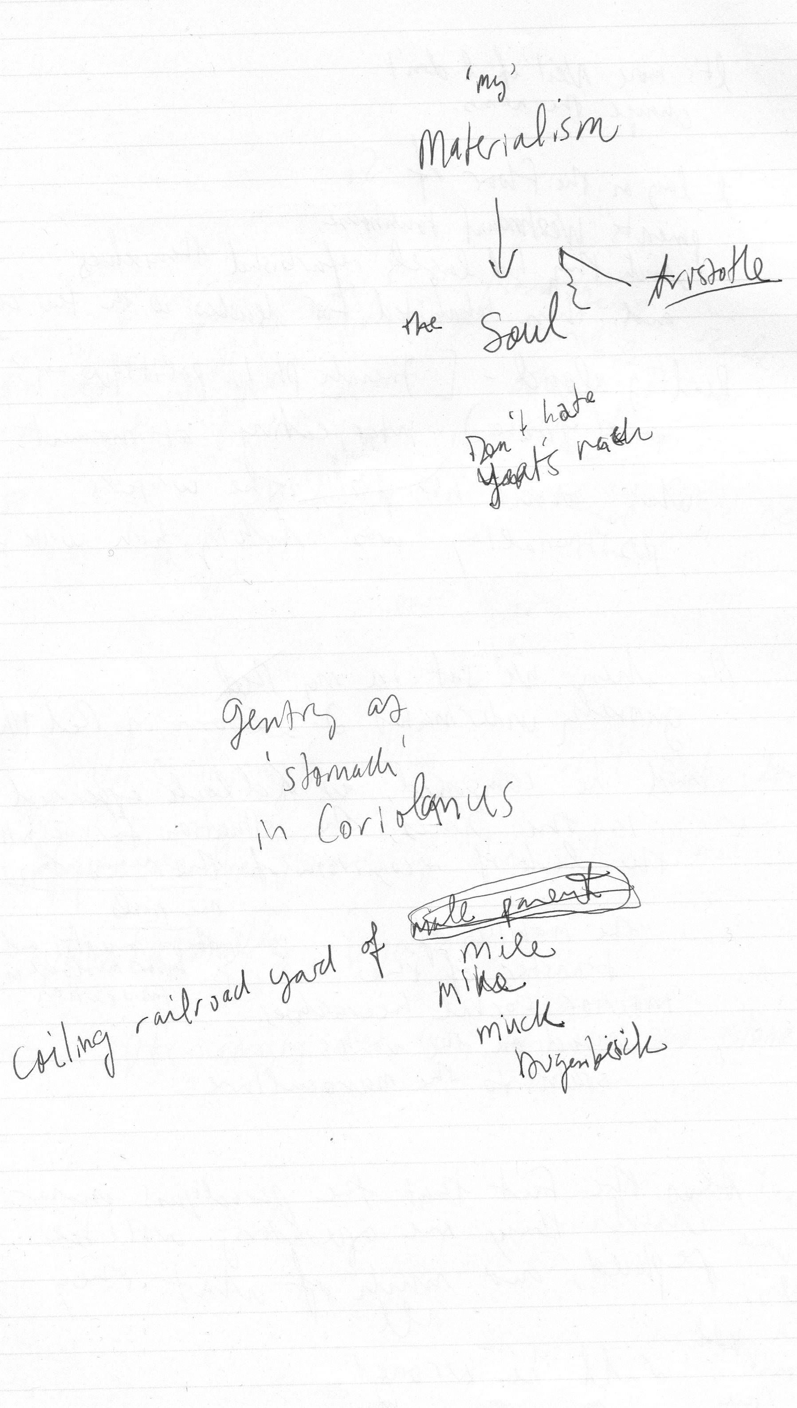

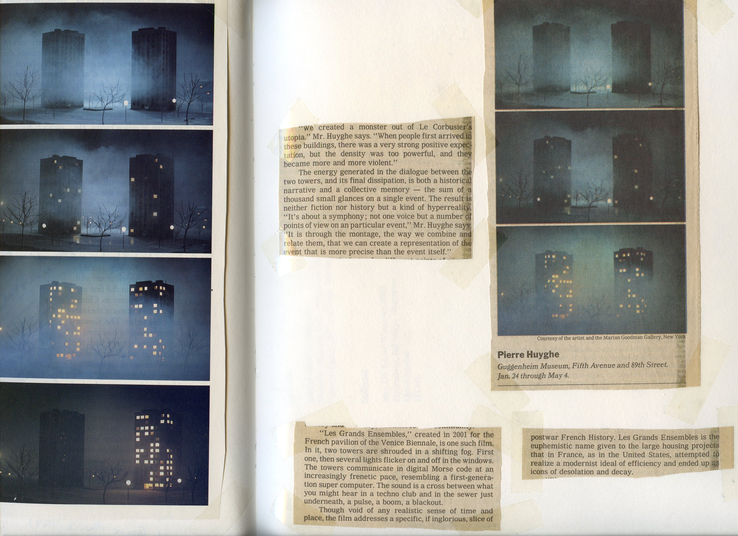

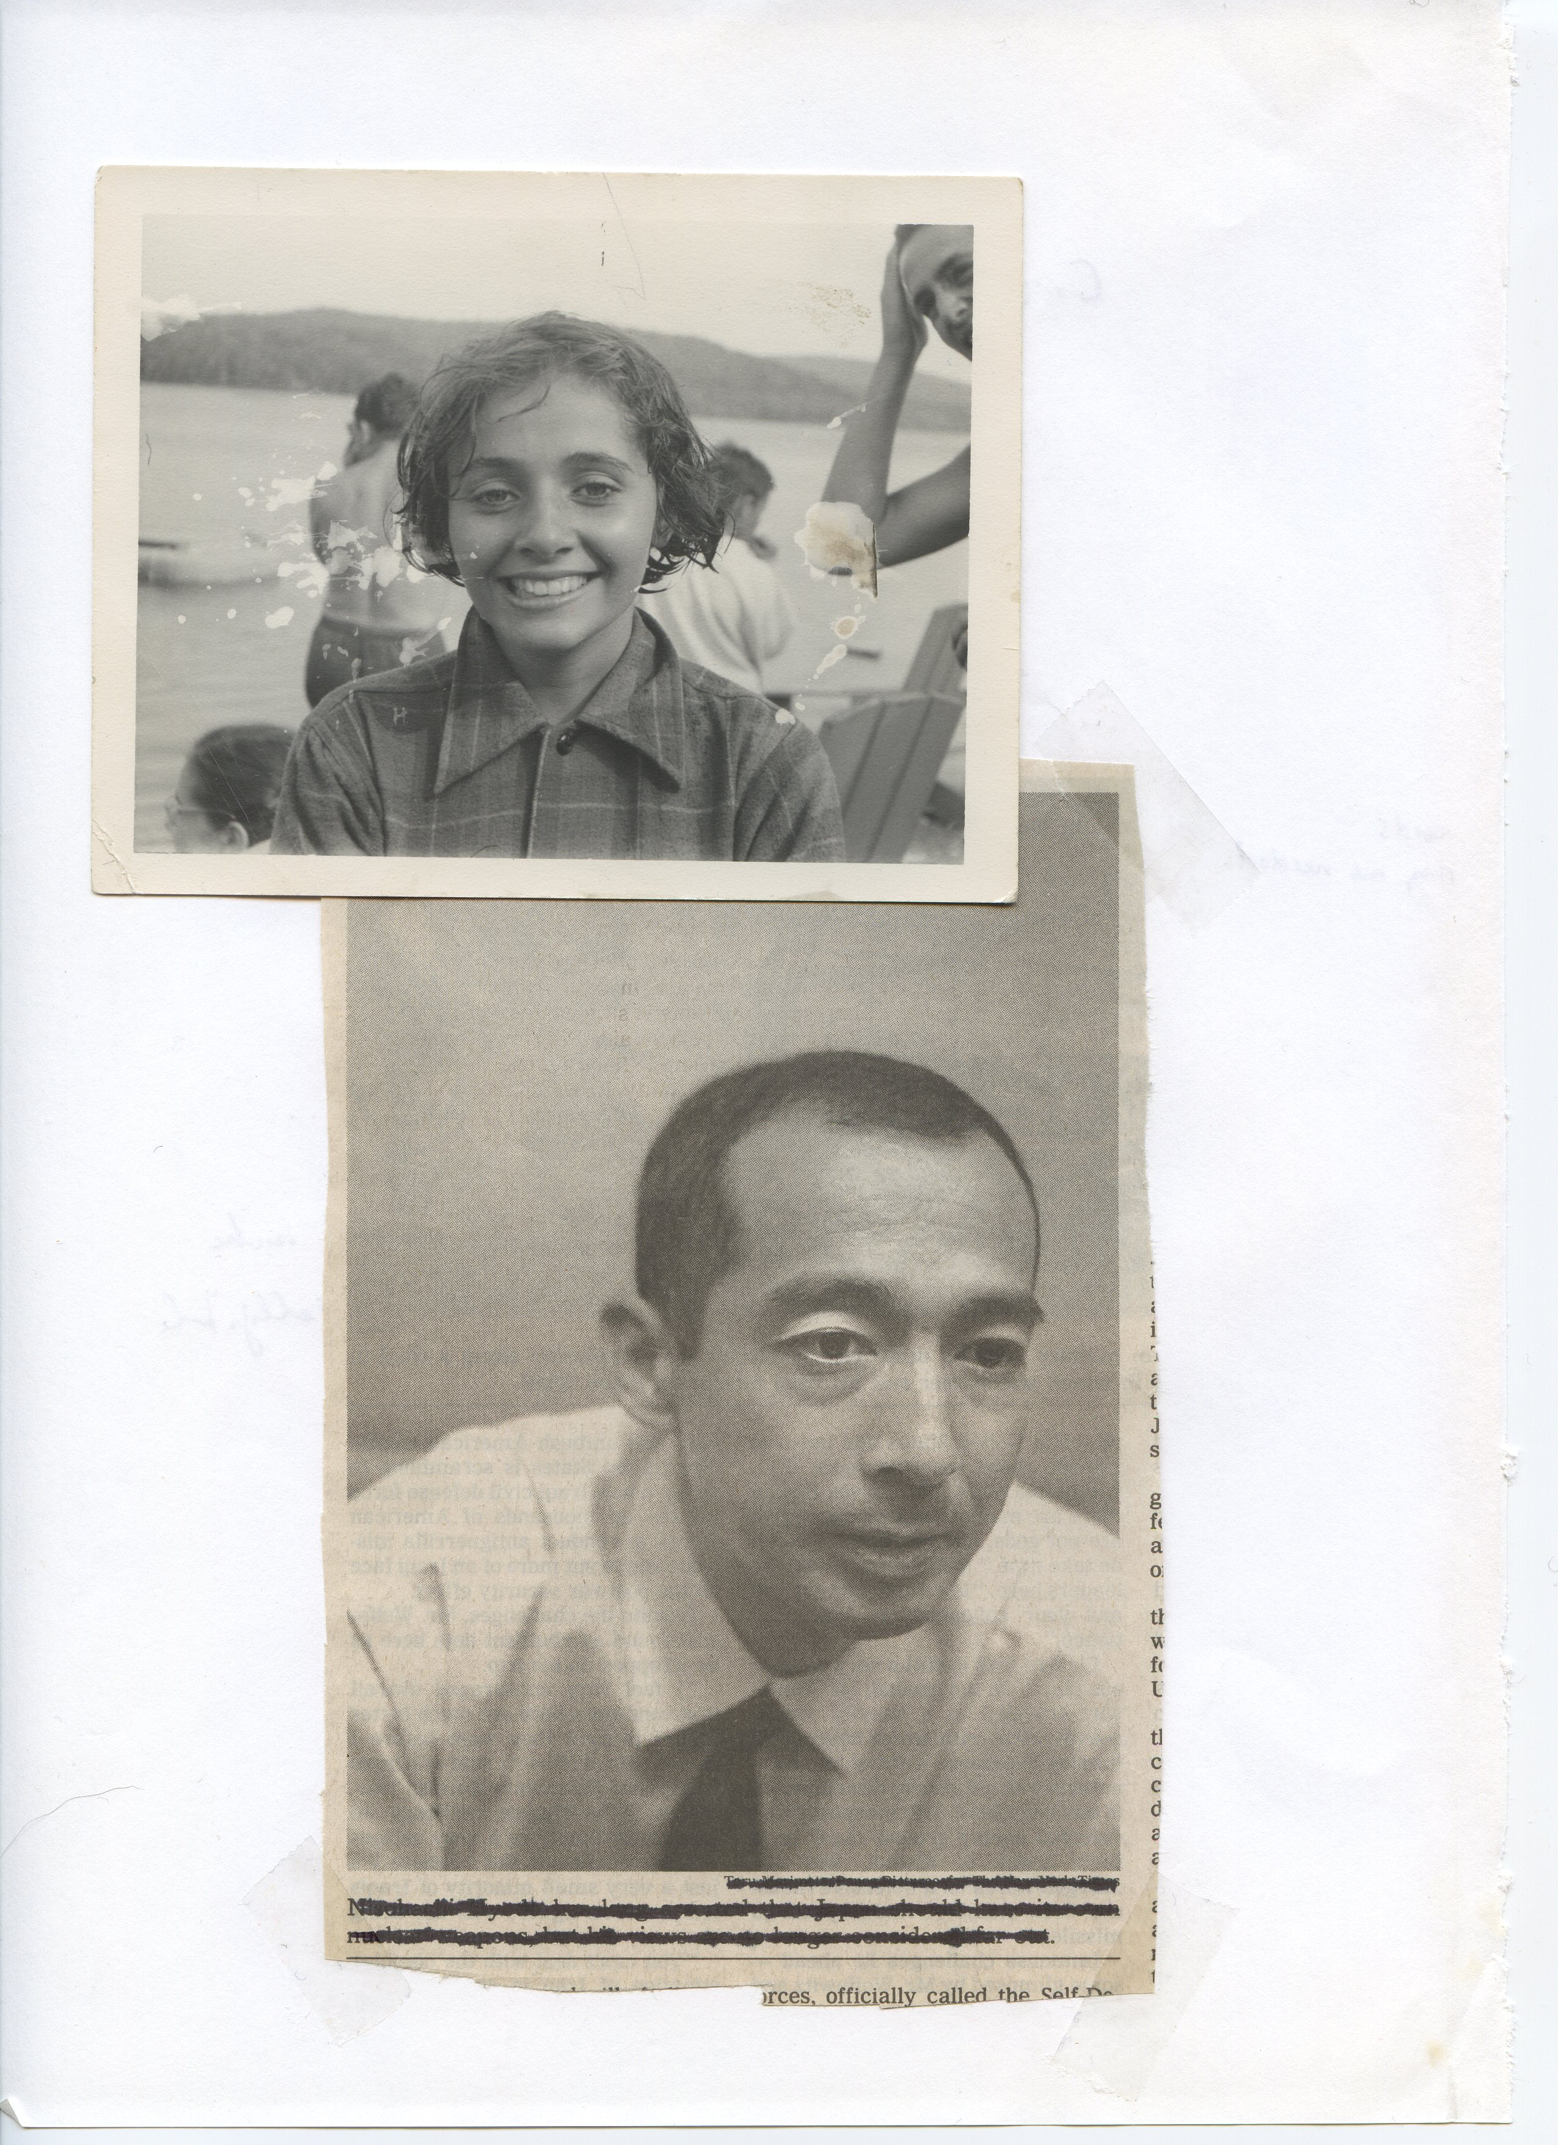

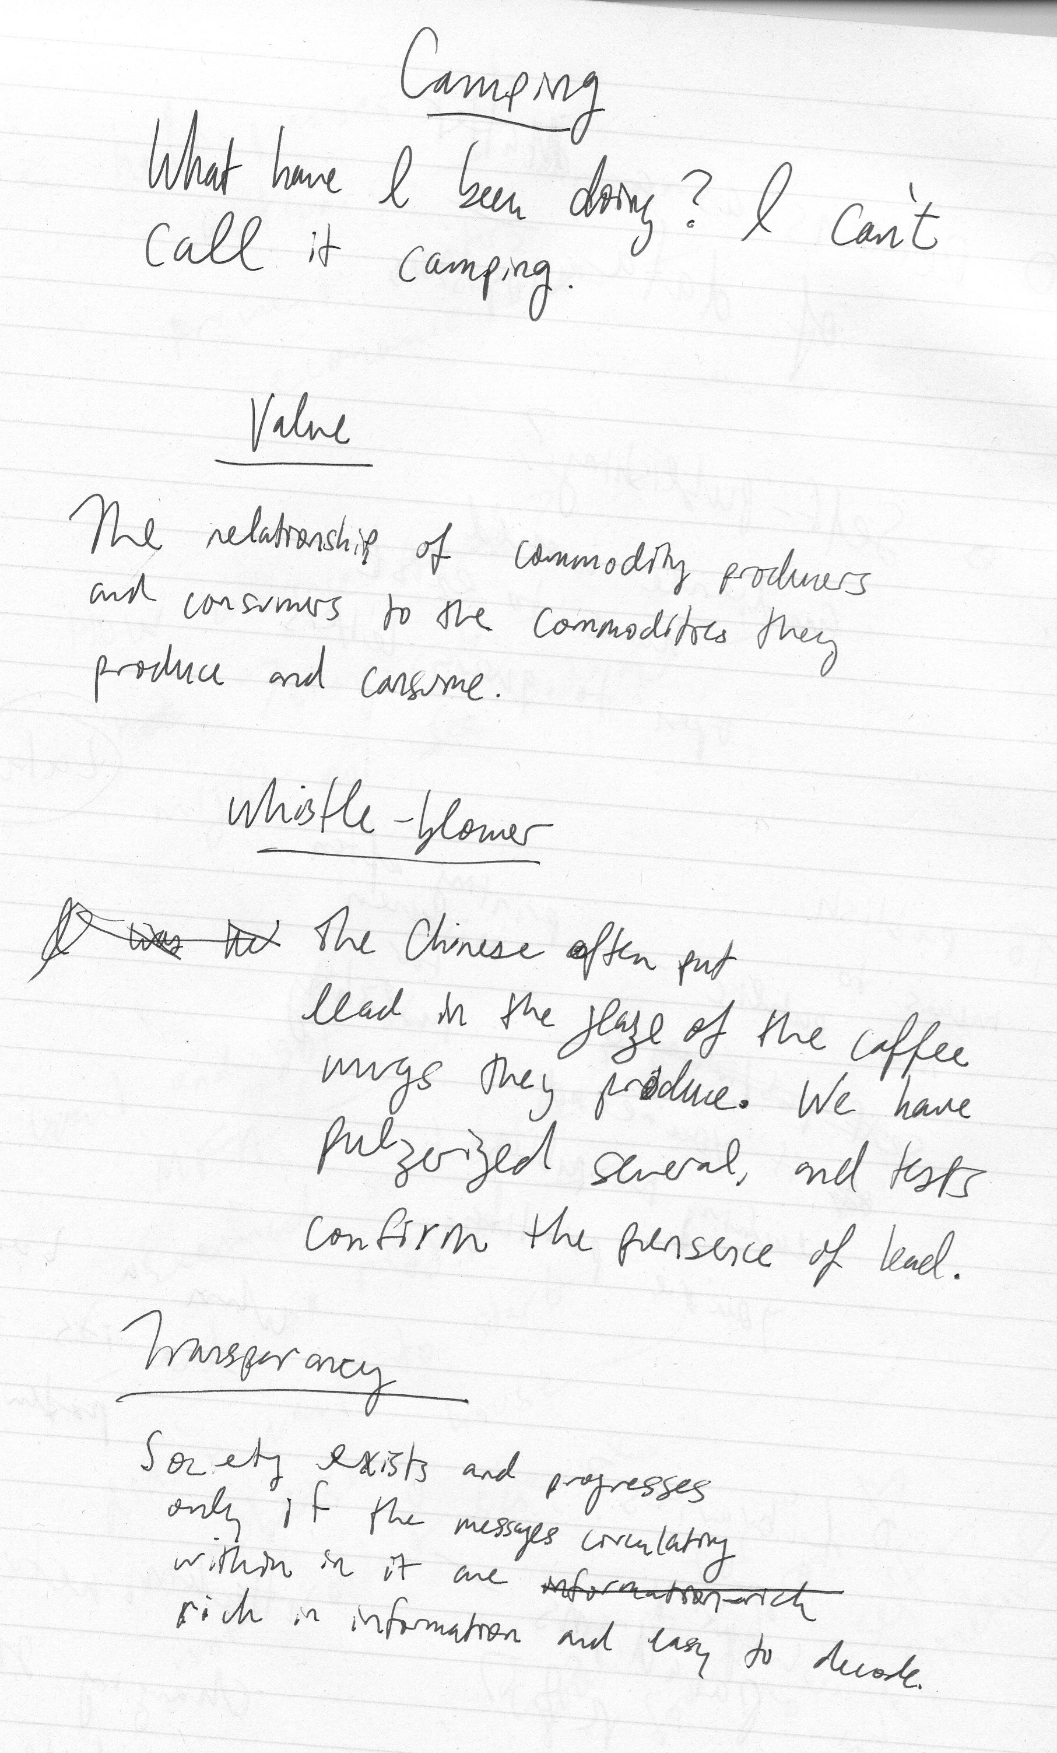

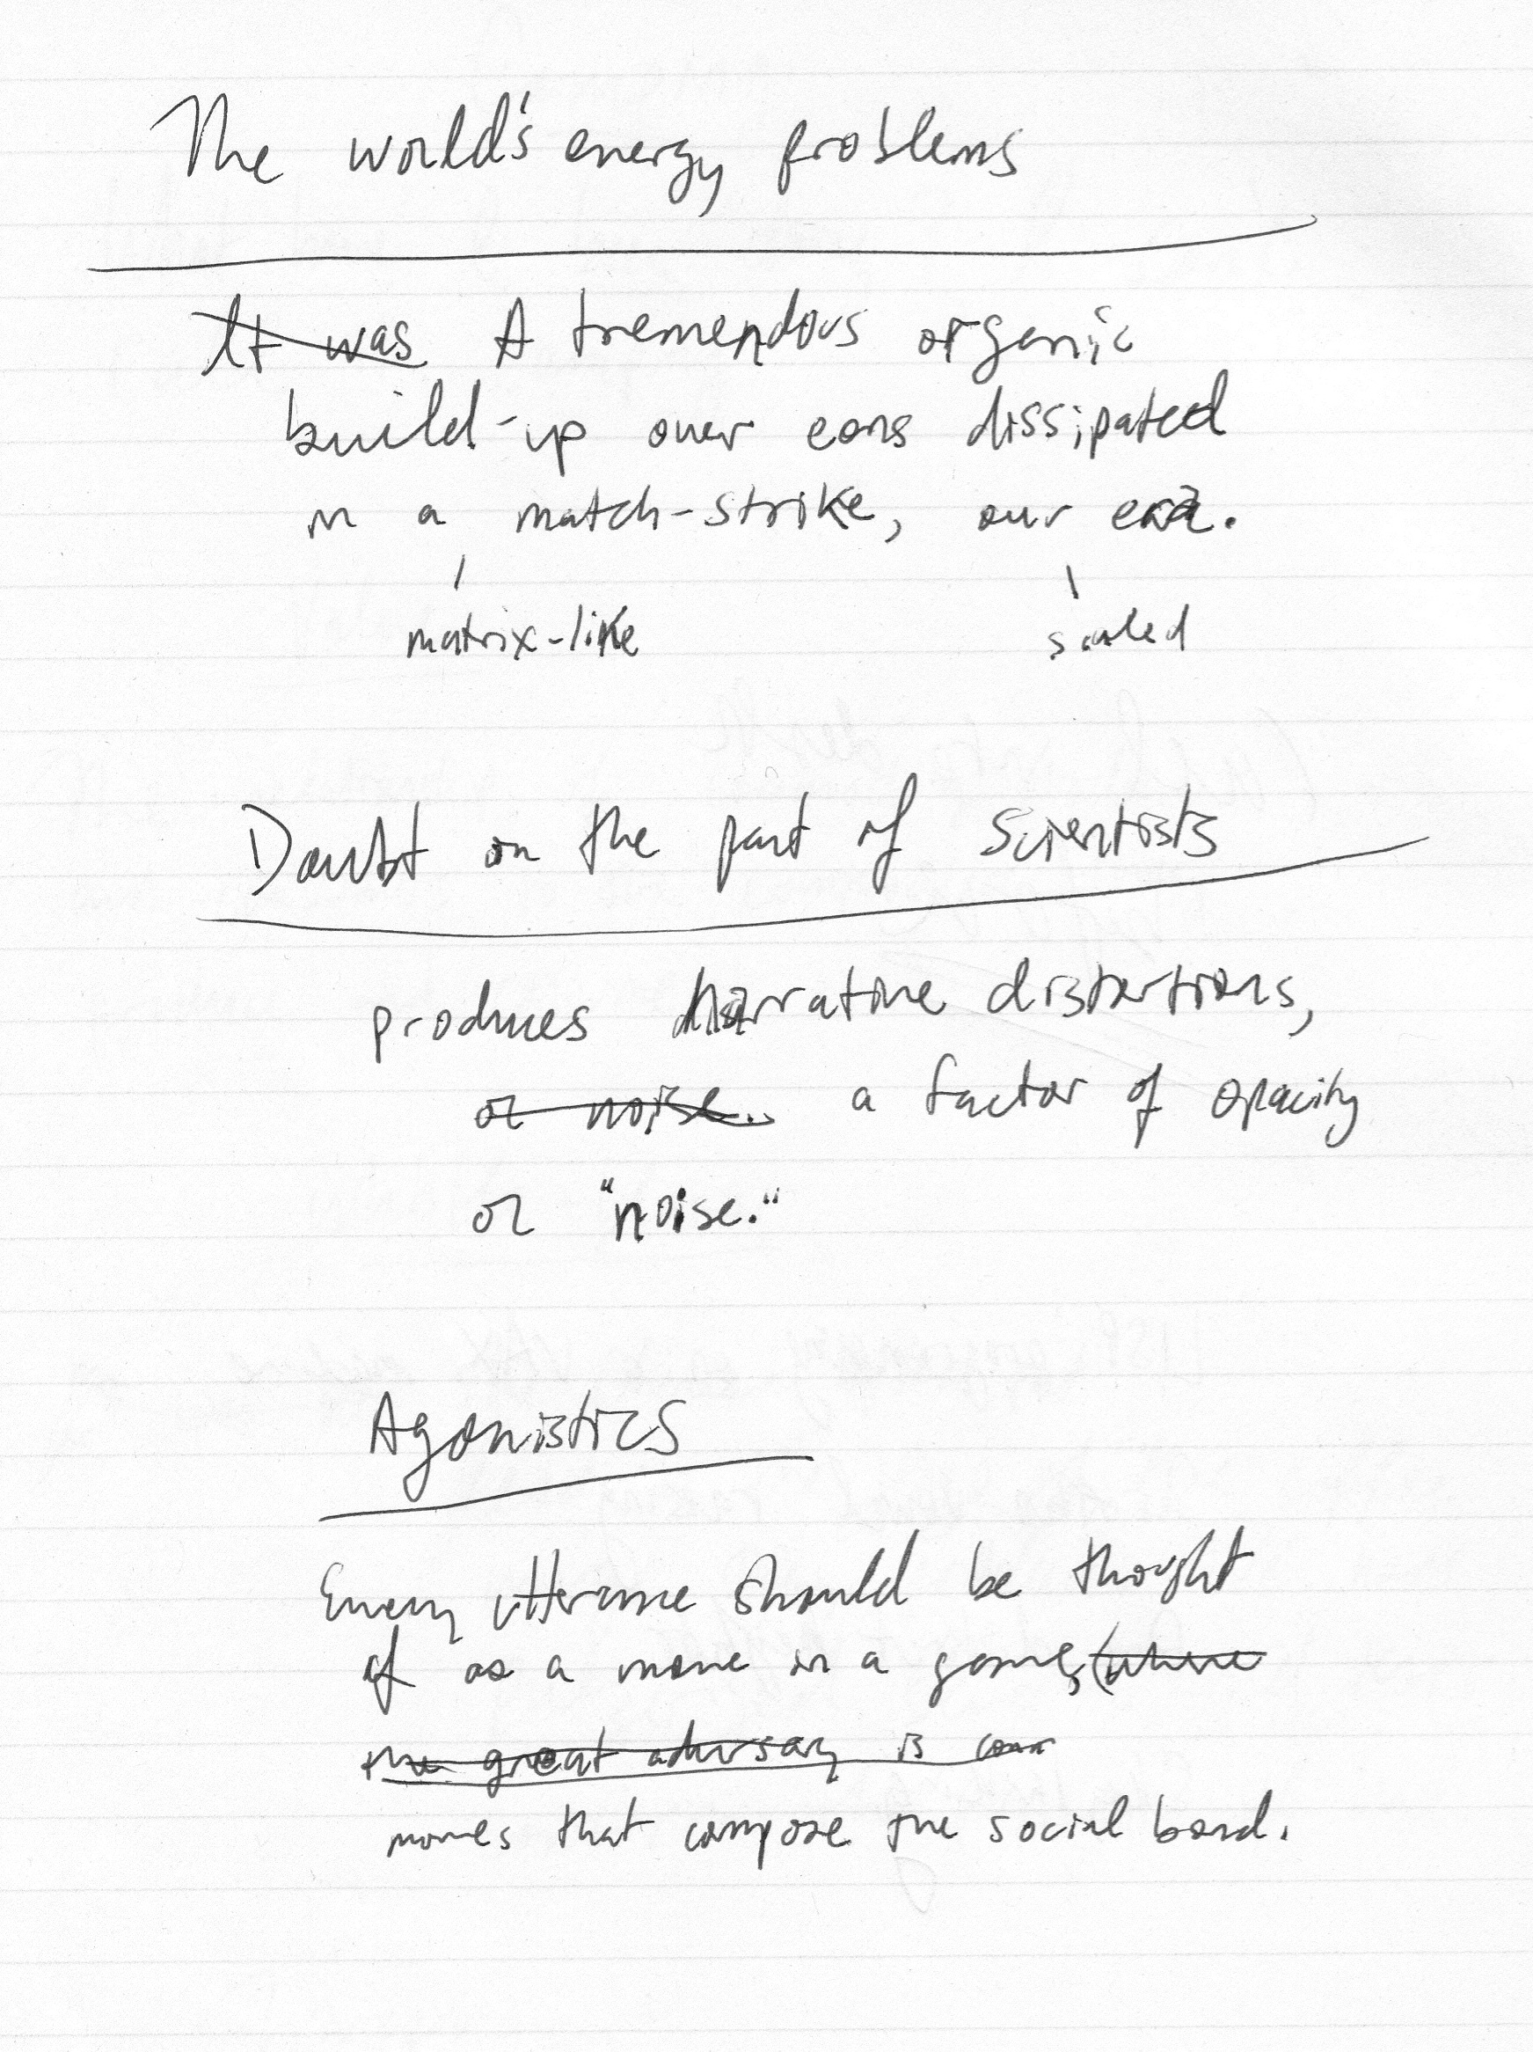

Second Schädel

The land’s a pocket mirror; you like to hold it down

and catch flashes of yourself.

It’s teeming. Greenpoint burns off its relations.

It’s a rimless procession: the sun, unbound but forced to sphere,

tentacles marble, an absorptive French blue, with particles

rising and falling in tandems, lolling in arcs.

Walking past the plant on Meserole, foot

blanket tangles and lips come down, calcium white.

Steam comes out the windows. It smells of perc.

Nocturnal Threshing

My hands enter the water and sort of separate

the wheat, gold and granular in the water.

It does not get cold enough anymore

to freeze the leaves. The pane shakes.

Nay saying bedside warm click of the lamp,

the yellowed shade, or melted yellow plastic top,

lets hair down to the mats on the floor. Climactic

sets of images to be read off as circled, spoked,

tuned, forced. The teeth of each

winding gear gapped, spaced unevenly, w/o

two quarters to rub together in i/o

folderol twiggy, jerry, quoit,

let it down

(“let down

uneas

ily”)

Several inhaler, Creation of evidence

spring injector, by stranded

false leads. sample.

Cloudy water

in the same beaten

pans. Red rice

floating

husks. Cast

alloy.

Bouleversement

A golf club

shoved

upside down

down the length

of the esophagus—

club head just showing

thought the teeth

Apartment-dwellers

in contractor’s bags

piled at curb for 12:30am

pickup

Other bags, filled just with blood,

opaque,

bulging, misshapen on the pavement,

drained for sodium

and pumped into

the streetlights

All the city’s dogs

electrocuted and left stiff,

piled.

Elevators run on long cords

in whatever direction they are needed.

Zero Point

Leading edge charged to millions of volts,

trailing edge charged to millions of volts—

Spectacle of youth-driven memory

remains acquisitive during development,

adding and storing complex

behaviors and symbol sets destined for—

planned obscenity—arrival.

Witnesses distracted as much as possible as

predecessors obliterated,

capacities for bio-powered beat-based behaviors

form the basis of distant

mutations,

fatal adaptation

to Fordism.

Coats are not exchanged for coats

and your exigency cannot confront me directly

smashing skulls on the ice repeatedly

to facilitate carbon dating of a single example,

relentlessly cited.

Five people not destroyed by their jobs;

five animals destroyed.

*

Brains wired for incredible violence

produced directly, cut, packaged,

shared and exported,

or hidden and

lied about, whatever.

Each ‘culture’ its own dissimulation or virtual machine

from extrémiste litérateur to practiced flak

to family adviser

it really works

just putting it out there

Parallel states

planes above

casting uniform

thus difficult-to-detect shadows

over and rays onto

the depleted skein

never actually deployed:

structures of representation

rule of law

terms of citizenship

intercourse between planes constant, vacuum between planes

sexless, and violent under development

and though the lower

be degraded to countervailing

construct or ‘pressure valve’,

enough energy

at points of contact

to boil the oceans six thousand times.

Just as a twist of the knob from 60,000 feet

rearranges the village or Syrianan contact among princes

and operatives,

scaled-down attacks allow discourse

to prepare the ground

so poetry can still operate

make form like choice.

What Did They Use to Cut Paper in Ancient Rome?

A caesars

which really troubles

Alfred,

Lord

Tenny Pump

unquantifiably—

to which to wit,

‘razors’

‘barrels’

‘contortions’

confounding liquids

and nasals.

Ok,

Heaviest one-syllable word

in English?

Strengths.

Heaviest rock in English canon?

Badger.

